**Name: Zhu Jin Shun**

**Student ID:22101071d**

**Question 2(Code and pictures of output will be posted for each question)**

**1)**

**Code:**

CREATE TABLE FLUX

(YEAR NUMBER,

WEEK NUMBER,

FROMDATE DATE,

TODATE DATE,

ILI_GOPC NUMBER,

ILI_PMP NUMBER,

H1 NUMBER,

H3 NUMBER,

B NUMBER,

AANDB NUMBER,

H1_PROPORTION NUMBER,

H3_PROPORTION NUMBER,

B_PROPORTION NUMBER,

AandB_PROPORTION NUMBER,

ILI_SCHOOL NUMBER,

ILI_NONSCHOOL NUMBER,

ADM_0_5 NUMBER,

ADM_6_11 NUMBER,

ADM_12_17 NUMBER,

ADM_18_49 NUMBER,

ADM_50_64 NUMBER,

ADM_65_HIGHER NUMBER,

ADM_ALL NUMBER,

ILI_AED NUMBER,

FEVER_CCCKG NUMBER,

FEVER_RCHE NUMBER,

ILI_CMP NUMBER,

SEVERECASE_0_17 NUMBER,

SEVERECASE_18_49 NUMBER,

SEVERECASE_50_64 NUMBER,

SEVERECASE_65_HIGHER NUMBER);

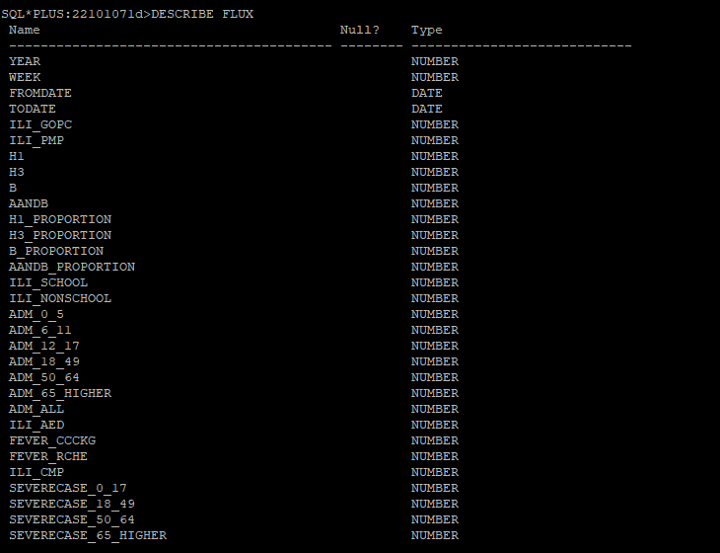

**2)**

**Too much input so only few code and a result of rows created in table for this question**

**Code:**

INSERT INTO FLUX VALUES (2014,1,TO_DATE('29/12/2013 00:00:00', 'dd/mm/yyyy hh24:mi:ss'),TO_DATE('04/01/2014 00:00:00', 'dd/mm/yyyy hh24:mi:ss'),NULL,45,93,111,64,268,0.043,0.0513,0.0296,0.1238,0,2,1.703,0.425,0.052,0.084,0.158,0.404,0.234,198,NULL,0.0009,3.86,0,1,3,1);

INSERT INTO FLUX VALUES (2014,2,TO_DATE('05/01/2014 00:00:00', 'dd/mm/yyyy hh24:mi:ss'),TO_DATE('11/01/2014 00:00:00', 'dd/mm/yyyy hh24:mi:ss'),NULL,43.8,230,140,109,479,0.0954,0.058,0.0452,0.1986,4,3,2.447,0.655,0.104,0.128,0.217,0.63,0.347,204.1,0.0088,0.0011,4.9,2,2,4,8);

INSERT INTO FLUX VALUES (2014,3,TO_DATE('12/01/2014 00:00:00', 'dd/mm/yyyy hh24:mi:ss'),TO_DATE('18/01/2014 00:00:00', 'dd/mm/yyyy hh24:mi:ss'),NULL,52.9,249,144,104,497,0.1079,0.0624,0.0451,0.2154,23,2,2.787,1.244,0.078,0.096,0.24,0.78,0.398,205,0.0104,0.0012,4.27,2,3,3,5);

INSERT INTO FLUX VALUES (2014,4,TO_DATE('19/01/2014 00:00:00', 'dd/mm/yyyy hh24:mi:ss'),TO_DATE('25/01/2014 00:00:00', 'dd/mm/yyyy hh24:mi:ss'),NULL,50.6,305,169,127,601,0.1178,0.0653,0.0491,0.2321,16,3,3.283,0.884,0.129,0.105,0.205,0.743,0.398,218.1,0.0127,0.0009,4.6,4,7,9,5);

INSERT INTO FLUX VALUES (2014,5,TO_DATE('26/01/2014 00:00:00', 'dd/mm/yyyy hh24:mi:ss'),TO_DATE('01/02/2014 00:00:00', 'dd/mm/yyyy hh24:mi:ss'),NULL,48.3,321,171,179,671,0.12,0.0639,0.0669,0.2507,7,3,3.314,0.687,0.311,0.174,0.334,1.062,0.512,254.1,NULL,0.0011,0.17,1,3,5,17);

INSERT INTO FLUX VALUES (2014,6,TO_DATE('02/02/2014 00:00:00', 'dd/mm/yyyy hh24:mi:ss'),TO_DATE('08/02/2014 00:00:00', 'dd/mm/yyyy hh24:mi:ss'),NULL,59.5,394,177,202,773,0.1295,0.0582,0.0664,0.2541,0,4,3.159,0.393,0.155,0.166,0.339,1.09,0.487,238.1,NULL,0.001,3.92,2,8,5,15);

INSERT INTO FLUX VALUES (2014,7,TO_DATE('09/02/2014 00:00:00', 'dd/mm/yyyy hh24:mi:ss'),TO_DATE('15/02/2014 00:00:00', 'dd/mm/yyyy hh24:mi:ss'),NULL,35.5,405,168,181,754,0.1565,0.0649,0.0699,0.2913,2,3,2.416,0.36,0.104,0.137,0.222,0.912,0.38,186.1,0.0071,0.0006,3.39,2,8,11,11);

INSERT INTO FLUX VALUES (2014,8,TO_DATE('16/02/2014 00:00:00', 'dd/mm/yyyy hh24:mi:ss'),TO_DATE('22/02/2014 00:00:00', 'dd/mm/yyyy hh24:mi:ss'),NULL,47.2,431,206,267,904,0.1497,0.0716,0.0927,0.314,19,10,3.314,1.276,0.233,0.102,0.257,1.062,0.48,200.3,0.0114,0.0011,2.58,3,6,8,8);

INSERT INTO FLUX VALUES (2014,9,TO_DATE('23/02/2014 00:00:00', 'dd/mm/yyyy hh24:mi:ss'),TO_DATE('01/03/2014 00:00:00', 'dd/mm/yyyy hh24:mi:ss'),NULL,47.9,411,178,291,880,0.1426,0.0618,0.101,0.3053,28,5,2.725,1.276,0.311,0.148,0.281,0.987,0.474,207.7,0.0128,0.0011,3.04,2,3,6,15);

INSERT INTO FLUX VALUES (2014,10,TO_DATE('02/03/2014 00:00:00', 'dd/mm/yyyy hh24:mi:ss'),TO_DATE('08/03/2014 00:00:00', 'dd/mm/yyyy hh24:mi:ss'),NULL,37.5,229,131,291,651,0.091,0.0521,0.1157,0.2587,17,9,2.23,0.785,0.155,0.154,0.252,0.837,0.397,195.2,0.0088,0.0011,2.87,0,4,9,9);

INSERT INTO FLUX VALUES (2014,11,TO_DATE('09/03/2014 00:00:00', 'dd/mm/yyyy hh24:mi:ss'),TO_DATE('15/03/2014 00:00:00', 'dd/mm/yyyy hh24:mi:ss'),NULL,55.3,122,78,288,488,0.0501,0.0321,0.1184,0.2006,11,3,1.518,0.556,0.259,0.061,0.181,0.649,0.273,200.5,0.0095,0.0009,2.87,1,3,3,7);

INSERT INTO FLUX VALUES (2014,12,TO_DATE('16/03/2014 00:00:00', 'dd/mm/yyyy hh24:mi:ss'),TO_DATE('22/03/2014 00:00:00', 'dd/mm/yyyy hh24:mi:ss'),NULL,51.4,110,60,299,469,0.0431,0.0235,0.1171,0.1837,9,3,1.332,0.655,0.104,0.076,0.14,0.63,0.255,208.4,0.0106,0.0015,3.04,0,1,2,13);…..

Rest of the inserting same as data provided by Dr.Vincent

**PICTURE:**

**3)**

**Code:**

SELECT DISTINCT WEEK

FROM FLUX

WHERE EXTRACT(MONTH FROM FROMDATE)!=EXTRACT(MONTH FROM TODATE);

**Picture:**

**4)**

**Code:**

SELECT YEAR,WEEK

FROM FLUX

WHERE H1>50 AND B>50;

**Picture:**

文本

**5)**

**Code:**

SELECT YEAR,AVG(H1) as avg_of_H1

FROM FLUX

WHERE WEEK!=5 AND WEEK!=12

GROUP BY YEAR

ORDER BY avg_of_H1 ASC;

**Picture:**

**6)**

**Code:**

SELECT WEEK,SUM(H1) as sum_of_H1

FROM FLUX

WHERE YEAR!=2016 AND YEAR!=2019

GROUP BY WEEK,YEAR

HAVING SUM(H1)>200

**Picture:**

**7)**

**Code:**

SELECT WEEK

FROM FLUX

WHERE H1>ALL(SELECT H1 FROM FLUX WHERE YEAR=2016 AND YEAR=2019);

**Picture:**

